- Resolve Merge Conflicts
- Create a merge conflict intentionally (two users editing the same line).
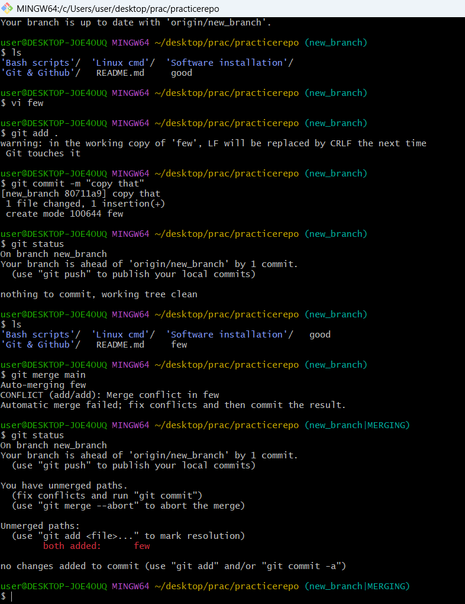
- Resolve the conflict and push the changes.
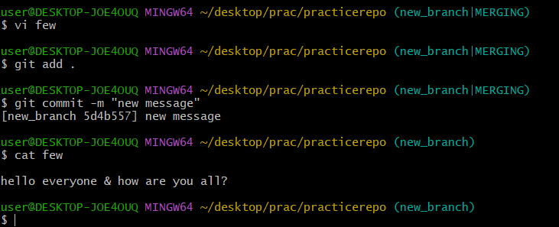
- Recover Deleted Branch
- Delete a local branch and then recover it using the reflog.
Use Command git reflog t osee the latest update of the deleted branch and than copy the commit then paste that commit in the commit as git checkout –b prevous br name commit id and hit enter.
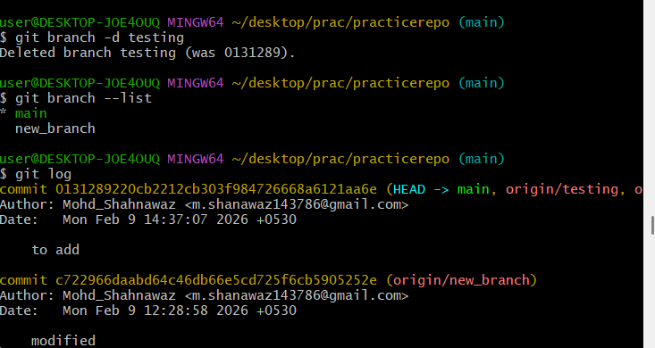
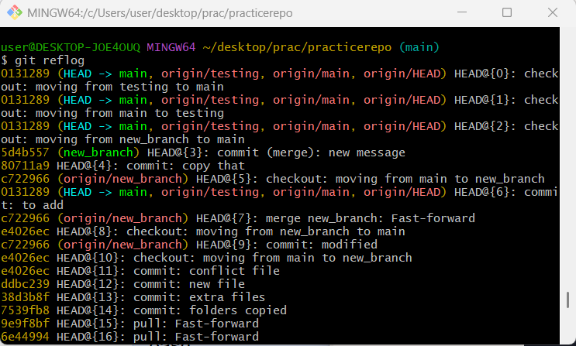
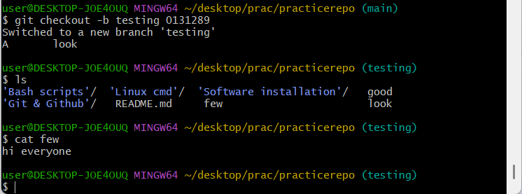
- Undo Wrong Push
- Push a wrong commit to GitHub, then undo it without losing history.
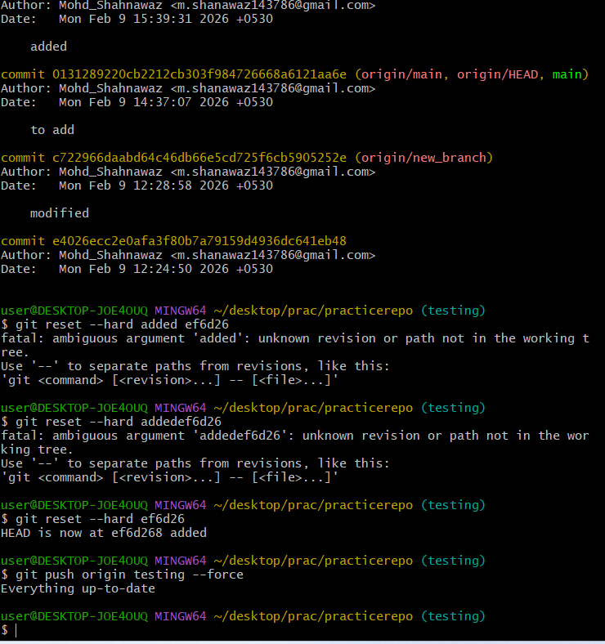

Amend a Commit
- Make a commit, then add a missing file to it using git commit --amend.
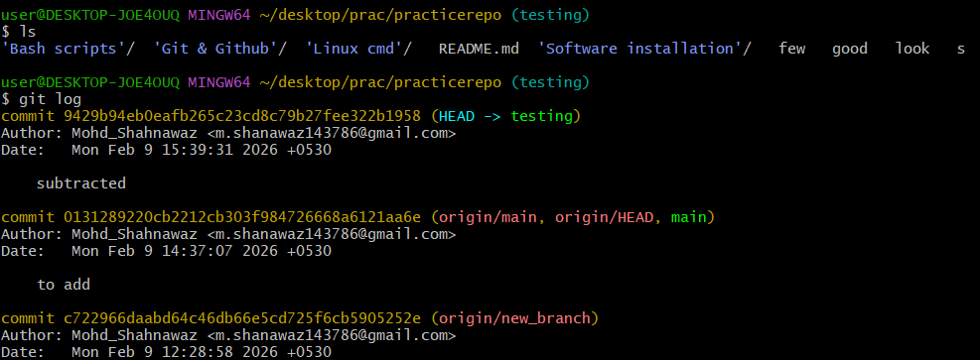
- Cherry-pick a Commit
- Take a specific commit from one branch and apply it to another branch.
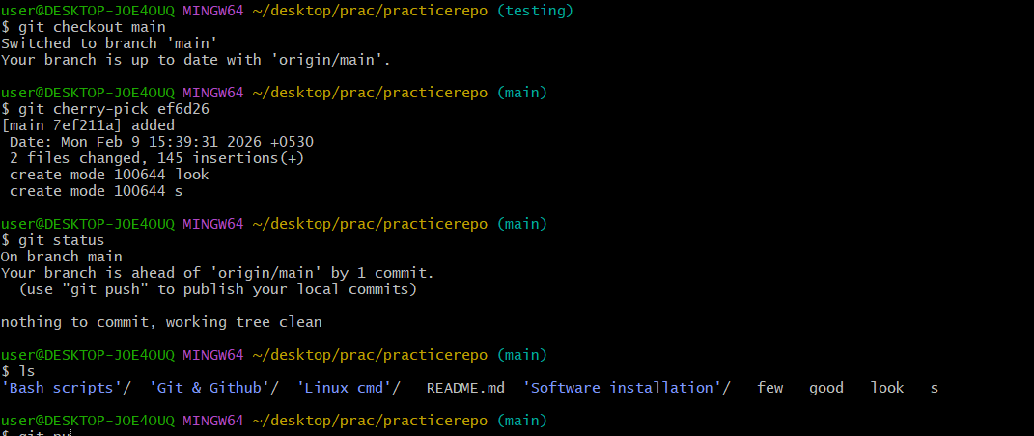

- Interactive Rebase
- Reorder and squash multiple commits into a single clean commit.
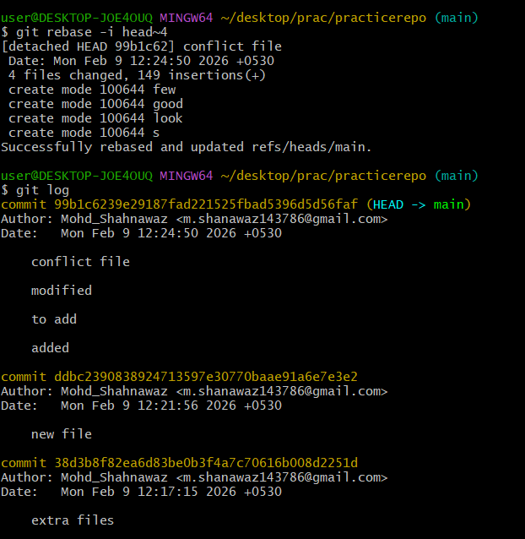
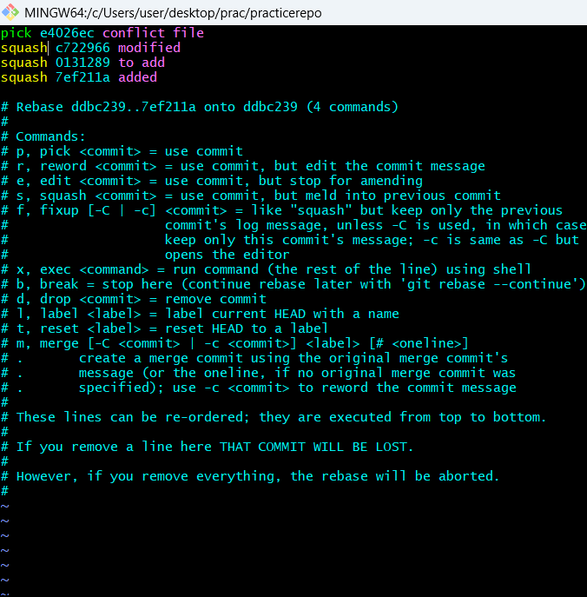

- Tagging & Release
- Create a version tag (v1.0), push it to GitHub, then delete and restore it.
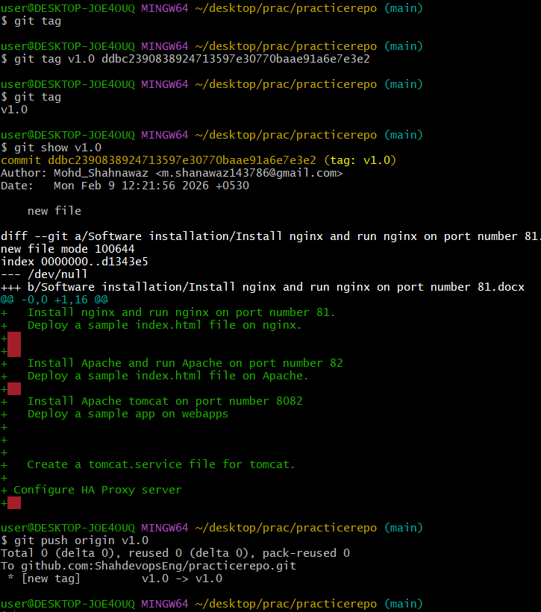
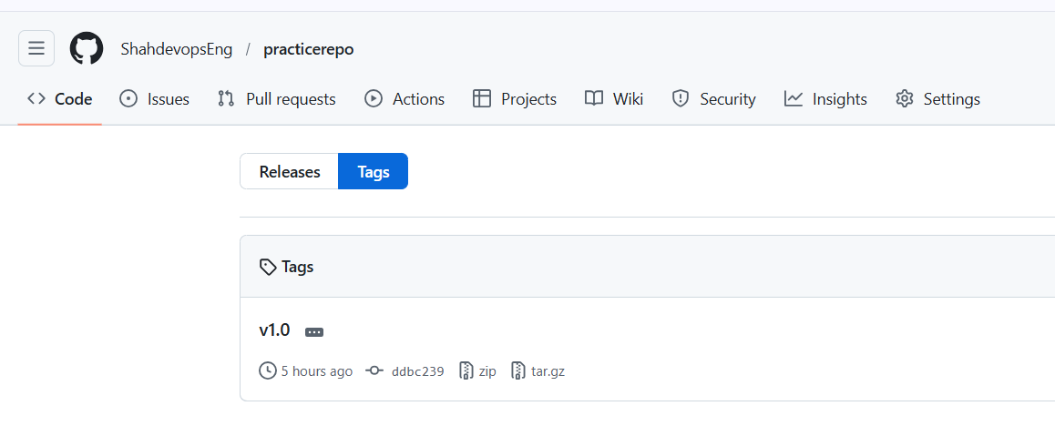
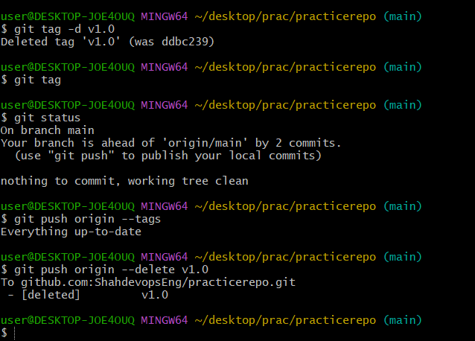
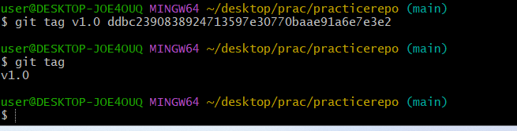

- Clone with Sparse Checkout
- Clone only a subdirectory of a repo using sparse checkout.
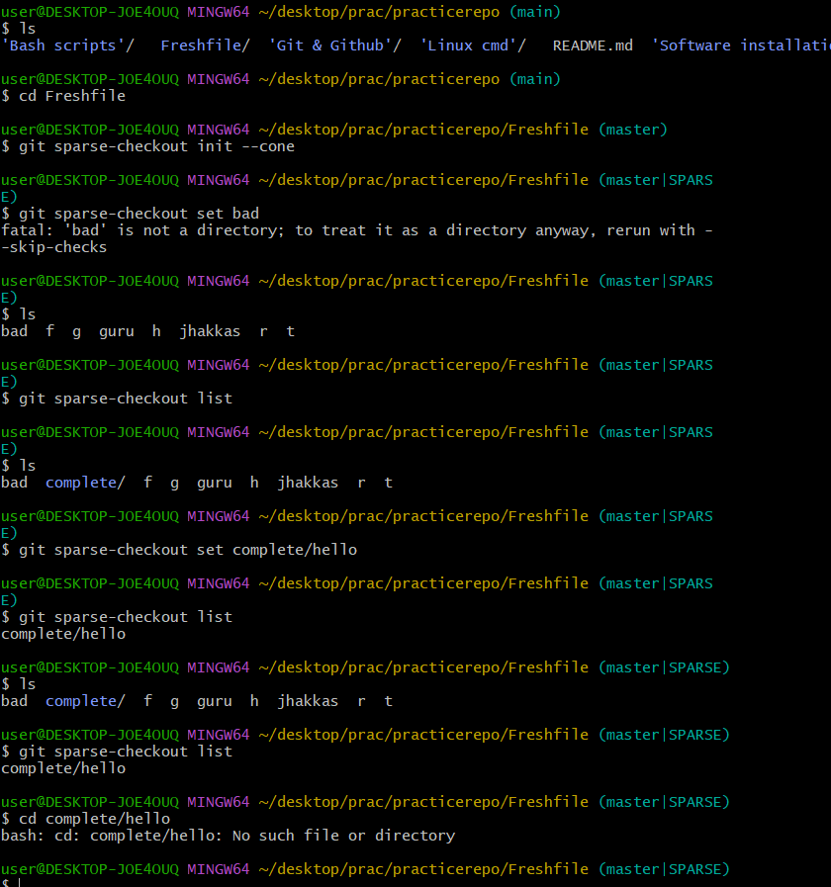

Reset vs Revert Challenge
- Demonstrate the difference between git reset --hard and git revert in a repo.
Git reset is used to undo the changes like I have created a file then added it to tracking area but before commiting you can move that file to untracking area but once you commited then you cant to reset.
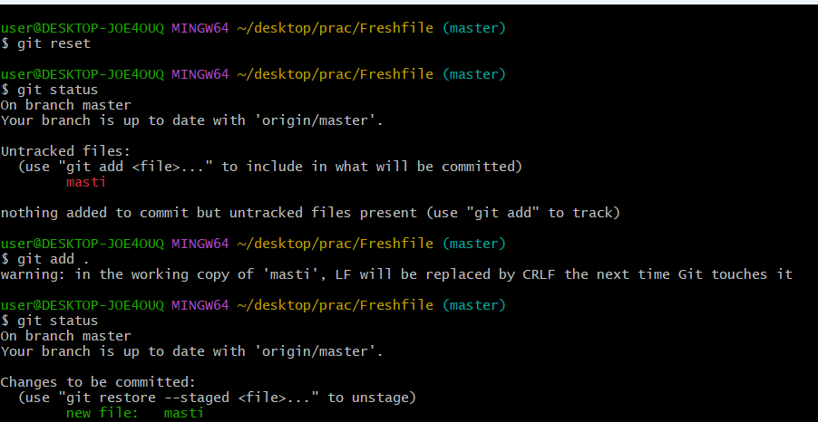
Git Revert means any changes you want in the commit message will be stores in a new commit message and their will be more than one commits displayed in git log for a single file.
Git revert logid you want to revert the commit
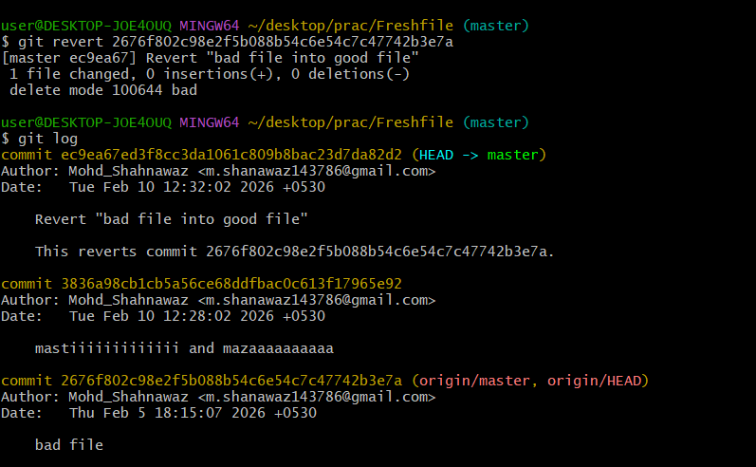

- Detached HEAD Challenge
- Checkout a specific commit (detached HEAD state) and create a new branch from it.
First open git log select any commit and give command git checkout commit id to create a new branch with commit id in detached head state.
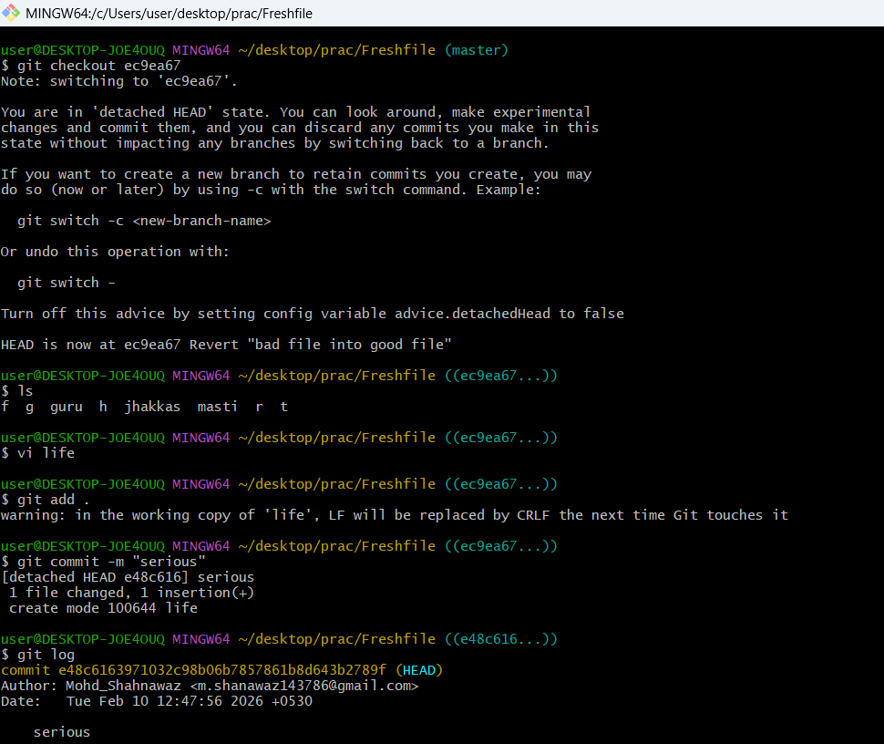

Git Hooks Challenge
- Configure a pre-commit hook to reject commits without a message format (e.g., must start with JIRA-XXX).
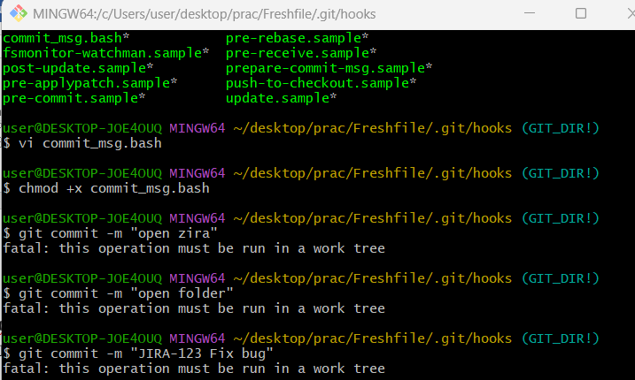
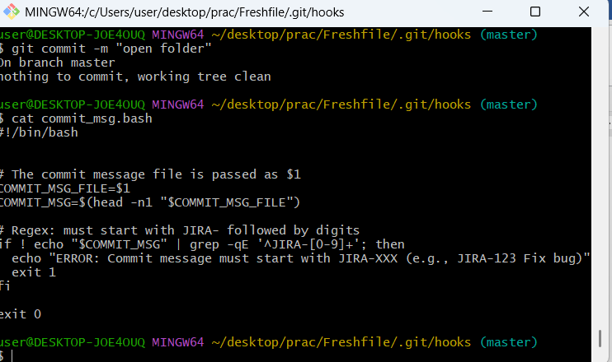

- Squash Merge vs Rebase Merge
- Show the difference between squash merge and rebase merge with evidence.
SQUASH MERGE
- Combines all commits from feature-branch into one single commit.
- You then commit that squashed change manually.
- History impact:
- The detailed commit history of the feature branch is lost (flattened).
- The main branch gets a clean, single commit representing the entire feature.
- When you want a tidy history (e.g., one commit per feature).
- Good for small features or bug fixes.
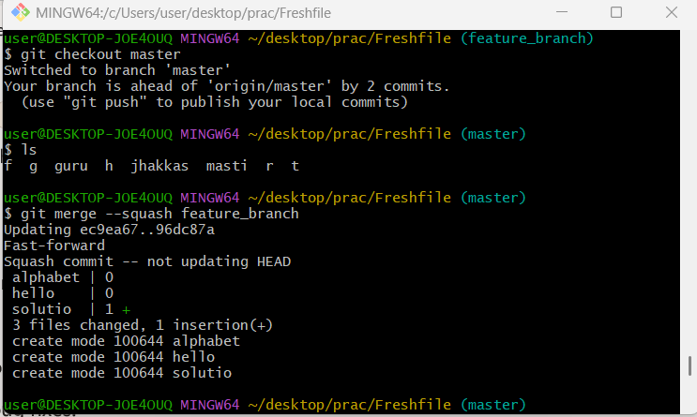
Rebase Merge
- Reapplies commits from your branch on top of another branch.
- Preserves individual commits but rewrites their history (new hashes).
- Maintains granular commit history.
- Creates a linear history (no merge commits).
- When you want to keep detailed commit history but avoid merge clutter.
- Good for collaborative projects where clean, linear history is valued.
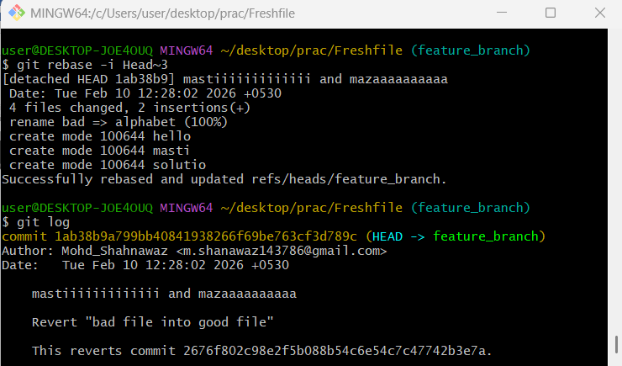

- Fork & Pull Request Workflow
- Fork a repo, make a change, and submit a pull request to the original repo.
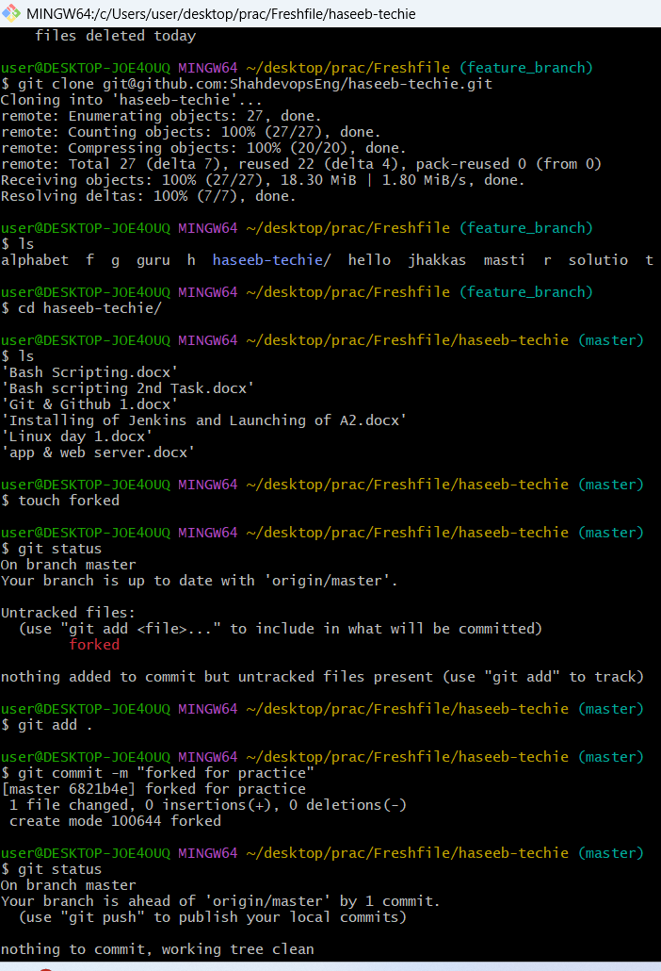

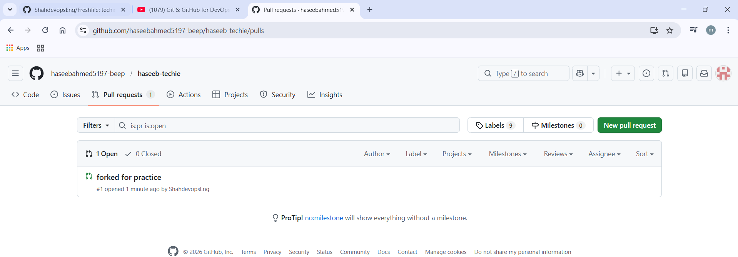
Recover Lost Commit
- Commit something, reset hard, and then recover it using git reflog.
